Veterans Last Patrol  Veterans Last Patrol Ceremony for Lt. Col. Judy Mutty, USAF Retired. Cathy Hampton and Carl Kilhoffer (top row, 2nd and 3rd from left). This is the second year the Chapter supported a VLP ceremony. Keith Reagan attended a Veterans Last Patrol ceremony for former USA Sergeant Richard Braun of Rising Sun, MD. SGT Braun passed away six months later and Keith was invited by the family to attend his funeral. | 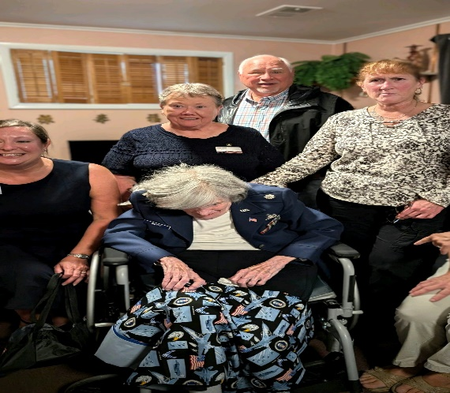  Advocacy in Action at State Level  Chapter Legislative Liaison, Bob Brown, was recognized as a Defense Community Champion, due in part to his work on behalf of MOAA. State Representative Mike Griffith presented the award at the Army Alliance breakfast and spoke about working with MOAA on bills he has proposed.
Harford County Veterans Day Poster and Essay Contest  Harford County Veterans Day Poster and Essay contest winners present at recognition ceremony | 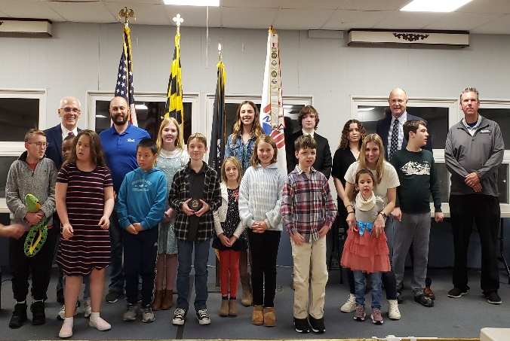
Advocacy in Action at State Level  Chapter Legislative Liaison, Bob Brown, was recognized as a Defense Community Champion due in part to his work on behalf of MOAA. State Representative Mike Griffith presented the award at the Army Alliance breakfast and spoke about working with MOAA on bills he has proposed. | 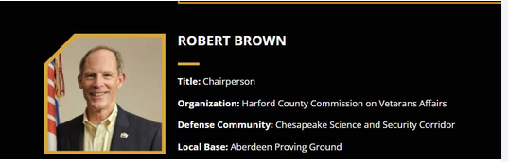
Supporting Wounded Warriors  The Chapter supported the annual Wounded Warrior event hosted by the APG Morale, Welfare, and Recreation Skeet and Trap Club. Servicemembers from Walter Reed Medical Center were invited to join the Skeet and Trap Club members for a day of shooting at the local range at APG South. | 