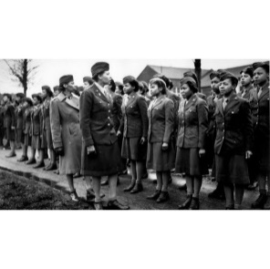
Name:
Address:
City, State Zip Code:

Date:

The Honorable Andy Harris
2334 Rayburn House Office Building
Washington, DC 20515-2001

Dear Representative Harris, :

I am writing you to ask that you co-sponsor the bi-partisan legislation, H.R.1012, To award a Congressional Gold Medal to the members of the Women's Army Corps who were assigned to the 6888th Central Postal Directory Battalion, known as the "Six Triple Eight".

The “Six Triple Eight” was the only all African-American Women’s Army Corps unit sent overseas during World War II. In February 1945, the “Six Triple Eight” was deployed to Europe to clear the approximately two-year backlog of mail for the nearly seven million members of the U.S. military, government personnel, and Red Cross workers serving in the European Theater of Operations. Commanded by then Major Charity Adams, they faced racism, sexism and worked in austere conditions. Despite this environment, they cleared a backlog of more than 17 million pieces of mail and packages in Birmingham, England, in three months by working three shifts daily and processing approximately 65,000 pieces of mail per shift. The “Six Triple Eight’ then relocated to Rouen and Paris, France, where they continued clearing the mail backlog, and adhering to their motto, “No Mail, Low Morale.” These women were set up to fail, but they stood up and delivered and exceeded all expectations. They improved our nation’s will to fight and led to our Allied Victory in WWII.

In February 1946, the last of the “Six Triple Eight” returned to the U.S. and Jim Crow laws that enforced segregation. The unit was disbanded at Fort Dix, New Jersey, without ceremony or official recognition of their accomplishments. Time of the essence to bestow this honor, only eight known veterans of this unheralded unit are still alive.

These are the Marylanders who served in this unit: Barnes, Agnes E PVT; Elzie, Vivian N 2LT; Jackson, Mary Rebecca CPL; Jones, Laura Mae PVT; Matthews, Murphy, Vashti PFC; Moore, Annie Beulah PVT; Nailor, Mary Catherine PVT; Noisette, Emily Olive PFC; Parker, Thelma Alice PVT; Philyaw, Ethel; Pollard, Hortense PFC; Pollitt, Lucy Geraldine PVT; Sydnor, Gloria A PVT; Tate, Catherine L PVT; Taylor, Gloria Phenryne PVT; Whyte, Grace Margaret PVT; Wilkins, Annie B PVT; Wilson, Eleanor Ann PVT; Young, Vivian Winifred SGT.

I appreciate your help and ask that you please send me a response letting me know if you co-sponsored H.R.1012 to award a Congressional Gold Medal to the “Six Triple Eight.”

Thank you for your time and considering my request. You may contact me at PH: email….

Sincerely,

